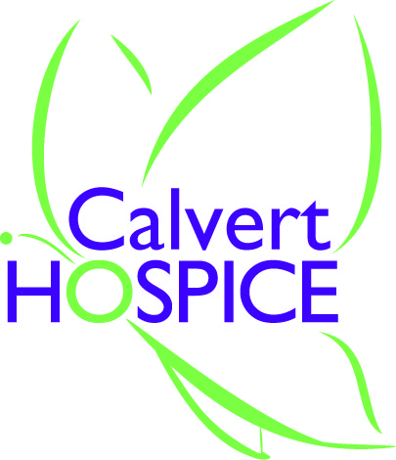
Calvert Hospice
238 Merrimac Court, Prince Frederick, MD 20678

Community Bereavement Support for Grief and Loss

____ I understand that Calvert Hospice offers short term grief counseling to help individuals cope with grief and loss in healthy ways.
_____ Grief counseling via zoom or in-person is being offered at a cost of $35.00 per session for up to 4 sessions; appointments are generally 45 minutes.
____ I understand that these sessions are not to be considered clinical counseling sessions nor are they intended as professional therapy. They are designed to be educational and supportive of persons as they seek to identify and connect with resources.
____ If additional support is desired, I understand that I may be informed of opportunities internal to Calvert Hospice’s Bereavement Program (such as a grief support group, workshop or bereavement class). For a more clinical, therapeutic counseling approach, assistance may be provided to me by identifying a variety of community resources, to include professional counseling and therapy. I understand that in this latter effort, Calvert Hospice functions as a kind of “clearing house” of information and does not endorse any individual services or providers external to Calvert Hospice.
____ I understand that the information I disclose is generally confidential and will not be released to any third party unless written consent is provided, except where required or permitted by law. Exceptions to confidentiality include, but are not limited to, situations where I may pose a threat of serious harm to myself or someone else, disclosure involving suspected child, elder or dependent elder abuse or court ordered disclosures.
____ If I need to cancel or reschedule a session, I agree to provide Calvert Hospice with 24 hours notice.

_________________________________________________
Printed Name

_________________________________________________
Signature

_________________________________________________
Date

